UNSTRUCTURED Field Experience Log & Reflection
Instructional Technology Department – Updated Summer 2015

Candidate: Gaberielle Miller | Mentor/Title: Barbara Lange | School/District: Russell Elementary/ Cobb County School District
Course: Instructional Technology Leadership |  | Professor/Semester: Angela Bacon/ Spring 2019

(This log contains space for up to 5 different field experiences for your 5 hours. It might be that you complete one field
experience totaling 5 hours! If you have fewer field experiences, just delete the extra pages. Thank you!)

Date(s) | 1st Field Experience Activity/Time | PSC Standard(s) | ISTE Standard(s)
1-10-19 | 2nd Grade Online Blog Update/ 30 minutes | 3.7  6.3 | 3a
2-4-19 | 2nd Grade Online Blog Update/ 30 minutes | 3.7  6.3 | 3a
2-7-19 | Planning for Behavior Bootcamp/30 minutes | 2.6  3.6  3.7 | 2f, 3f, 3g
3-4-19 | 2nd Grade Online Blog Update/ 30 minutes | 3.7  6.3 | 3a
3-13-19 | Technology info with shared with teacher/ 30 minutes | 1.1 | 1a
3-19-19 | Behavior Bootcamp/ 1.5 hours | 2.6  3.6  3.7 | 2f, 3f, 3g
4-5-19 | 2nd Grade Online Blog Update/ 30 minutes | 3.7  6.3 | 3a
4-13-19 | Microsoft Teams Training/ 1 hour | 6.1 | 6a, 6b
First Name/Last Name/Title of an individual who can verify this experience:  Walida Byars  Charlotte Seel  Alexis Lauderdale | Signature of the individual who can verify this experience:  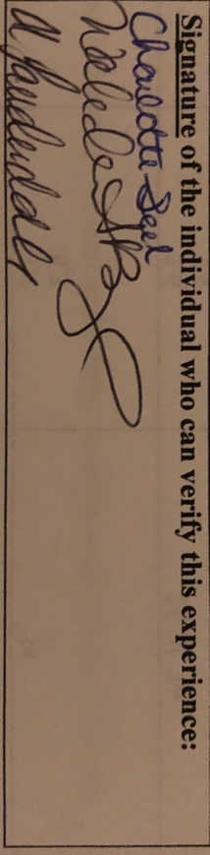

DIVERSITY
(Place an X in the box representing the race/ethnicity and subgroups involved in this field experience.)
Ethnicity | P-12 Faculty/Staff |  |  |  | P-12 Students
 | P-2 | 3-5 | 6-8 | 9-12 | P-2 | 3-5 | 6-8 | 9-12
Race/Ethnicity:
Asian
Black | X | X
Hispanic | X
Native American/Alaskan Native
White | X
Multiracial
Subgroups:
Students with Disabilities
Limited English Proficiency
Eligible for Free/Reduced Meals

Reflection
(Minimum of 3-4 sentences per question)
1. Briefly describe the field experience. What did you learn about technology coaching and technology leadership from completing this field experience?

Throughout the field experiences listed above, I had the opportunity to collaborate to share important information to the 2nd grade parents. I also was able to share my experience about technology and encourage one of my colleagues to pursue a degree in technology. I was also able to continue my learning by attending a training on Microsoft Teams.

2. How did this learning relate to the knowledge (what must you know), skills (what must you be able to do) and dispositions (attitudes, beliefs, enthusiasm) required of a technology facilitator or technology leader? (Refer to the standards you selected above. Use the language of the PSC standards in your answer and reflect on all 3—knowledge, skills, and dispositions.)
Knowledge – This learning helped relate to the knowledge I must know because I am now able to communicate and collaborate digitally with parents and colleagues that’s apart (blogs). I was also able to continue my growth in knowledge and skills of current and emerging technologies (Microsoft Teams). Furthermore, I was able to share our school’s technology vision amongst my grade level and with a third-grade teacher.

Skills – In order to complete my field experience, I had to continue to research current technology tools as well learn about new tools.

Dispositions – To effectively complete the tasks associated with my field experiences, I had to be positive when informing others about current emerging technologies.
3. Describe how this field experience impacted school improvement, faculty development or student learning at your school. How can the impact be assessed?
- I was able to use an online blog to inform parents about the things their child will be learning in school. Blogging saves on paper and gives teachers another way to communicate with parents digitally.

- I was able to support facilitators as they gave parents strategies when it comes to behavior. The Behavior Camp was recorded by me and shared online for parents who could not join the meeting. The boot camp is a great way to get parents involved.

- I was also able to share a few technology resources with my grade level and a third-grade teacher. The programs shown will lead to an increase in student engagement.

I think all of activities that I completed during my field experience could be evaluated by a simple checklist.

