UNSTRUCTURED Field Experience Log & Reflection
Instructional Technology Department – Updated Summer 2015

Candidate: Gaberielle Miller | Mentor/Title: Barbara Lange | School/District: Russell Elementary/ Cobb County School District
Course: ITEC 7430 Internet Tools in the Classroom |  | Professor/Semester: Dr. Laurie Dias/ Spring 2019

(This log contains space for up to 5 different field experiences for your 5 hours. It might be that you complete one field
experience totaling 5 hours! If you have fewer field experiences, just delete the extra pages. Thank you!)

Date(s) | 1st Field Experience Activity/Time | PSC Standard(s) | ISTE Standard(s)
March 25:  March 26:  March 27:  March 28:  March 29: April 8:  April 9:  April 10:  April 11: | 7:30-8:00 and 2:00-2:30  7:30-8:00 and 2:00-2:30  7:30-8:00 and 2:00-2:30  7:30-8:00 and 2:00-2:30  7:30-8:00 and 2:00-2:30  2:00-2:30  7:30-8:00 and 2:00-2:30  7:30-8:00 and 2:00-2:30  7:30-8:00 and 2:00-2:30  [8.5 hours] | 1.2, 2.1, 2.2, 2.3, 2.5, 2.6, 3.2, 3.3, | 1b, 2a,2b, 2c, 2e, 2f, 3b, 3c
First Name/Last Name/Title of an individual who can verify this experience: Alexis Lauderdale  Walida Byars  Charlotte Seel | Signature of the individual who can verify this experience:  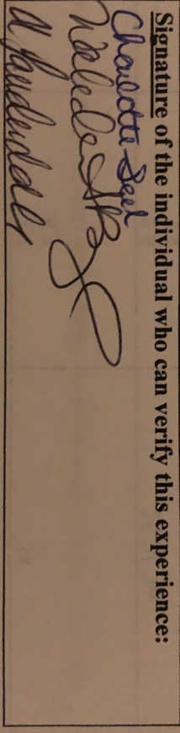

DIVERSITY
(Place an X in the box representing the race/ethnicity and subgroups involved in this field experience.)
Ethnicity | P-12 Faculty/Staff |  |  |  | P-12 Students
 | P-2 | 3-5 | 6-8 | 9-12 | P-2 | 3-5 | 6-8 | 9-12
Race/Ethnicity:
Asian
Black
Hispanic |  |  |  |  | X
Native American/Alaskan Native
White
Multiracial
Subgroups:
Students with Disabilities
Limited English Proficiency |  |  |  |  | X
Eligible for Free/Reduced Meals |  |  |  |  | X

Reflection
(Minimum of 3-4 sentences per question)
1. Briefly describe the field experience. What did you learn about technology coaching and technology leadership from completing this field experience?
I am a second-grade Dual Language Immersion (DLI) teacher. I teach students reading, writing, and phonics in English. The English teacher also reinforces content that students learn in math, science, and social studies. I also serve as their ESOL teacher. For this field experience, I worked with two of my second-grade students in a small group setting. The two students have made significant growth over the school year. However, they are not on grade level. Consequently, I decided to focus on areas that would extend their reading and writing skills. We used Reading A-Z, Brainpop Jr., and Photo Story 3 as strategies to support my ELL. From this experience, I learned that it is important to preview and review vocabulary with students. I also learned that it is essential to build upon students’ skills through building background knowledge.

2. How did this learning relate to the knowledge (what must you know), skills (what must you be able to do) and dispositions (attitudes, beliefs, enthusiasm) required of a technology facilitator or technology leader? (Refer to the standards you selected above. Use the language of the PSC standards in your answer and reflect on all 3—knowledge, skills, and dispositions.)
Knowledge – This learning experience helped me to research best practices as well as technology that supports ELL.

Skills – This field experience helped me by providing additional differentiation tools to make sure that my ELL are successful and have full access to the curriculum.
Dispositions – This field experience gave me the opportunity to develop and practice professional disposition for working with all students.

3. Describe how this field experience impacted school improvement, faculty development or student learning at your school. How can the impact be assessed? This field experience will impact my school in the future because I am now able to provide instructional practices that facilitate learning and assess English Language Learners. I plan on sharing this research with my 2nd - grade team.

