UNSTRUCTURED Field Experience Log & Reflection
Instructional Technology Department – Updated Summer 2015

Candidate: Gaberielle Miller | Mentor/Title: Barbara Lange | School/District: Russell Elementary/ Cobb County School District
Course: Multimedia and Web Design in Education |  | Professor/Semester: Dr. Yi Jin/ Fall 2018

(This log contains space for up to 5 different field experiences for your 5 hours. It might be that you complete one field
experience totaling 5 hours! If you have fewer field experiences, just delete the extra pages. Thank you!)

Date(s) | 1st Field Experience Activity/Time | PSC Standard(s) | ISTE Standard(s)
8-8-18 | Class Dojo/ 45 minutes | 2.3  3.2  3.6  6.3 | 3a, 3b, 3f, 5a
8-10-18 | Class Dojo/ 15 minutes | 2.3  3.2  3.6  6.3 | 3a, 3b, 3f, 5a
9-1-18 | 2nd Grade Online Blog Update/ 30 minutes | 3.7  6.3 | 3a
10-1-18 | 2nd Grade Online Blog Update/ 30 minutes | 3.7  6.3 | 3a
11-1-18 | 2nd Grade Online Blog Update/ 30 minutes | 3.7  6.3 | 3a
11-15-18 | SMART Exchange/ 60 minutes | 2.3  3.2  3.6 | 3a, 3b, 3f, 5a
12-1-18 | 2nd Grade Online Blog Update/ 30 minutes | 3.7  6.3 | 3a
12-4-18 | Seesaw (Teacher was not able to attend the scheduled PD.)/ 60 minutes | 2.3  3.2  3.6  6.3 | 3a, 3b, 3f, 5a
First Name/Last Name/Title of an individual who can verify this experience:  Deborah Brown-Bell  Jasmine McBride  Megan McCormick  Walida Byars  Caren Murry  Charlotte Seel  Ana Portela | Signature of the individual who can verify this experience:  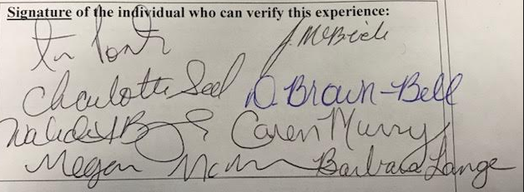

DIVERSITY
(Place an X in the box representing the race/ethnicity and subgroups involved in this field experience.)
Ethnicity | P-12 Faculty/Staff |  |  |  | P-12 Students
 | P-2 | 3-5 | 6-8 | 9-12 | P-2 | 3-5 | 6-8 | 9-12
Race/Ethnicity:
Asian
Black | X | X
Hispanic
Native American/Alaskan Native
White | X
Multiracial
Subgroups:
Students with Disabilities
Limited English Proficiency
Eligible for Free/Reduced Meals

Reflection

(Minimum of 3-4 sentences per question)
1. Briefly describe the field experience. What did you learn about technology coaching and technology leadership from completing this field experience?

Throughout the field experiences listed above, had the opportunity to collaborate with my colleagues and assist them with the use of digital tools to engage their students and to communicate with parents. I also had the chance to utilize digital tools to communicate with parents. My field experience has helped me model and promote digital citizenship and communicate with parents efficiently.

2. How did this learning relate to the knowledge (what must you know), skills (what must you be able to do) and dispositions (attitudes, beliefs, enthusiasm) required of a technology facilitator or technology leader? (Refer to the standards you selected above. Use the language of the PSC standards in your answer and reflect on all 3—knowledge, skills, and dispositions.)
Knowledge – This learning helped relate to the knowledge I must know because I am now able to select, evaluate, and facilitate how to use digital tools and resources to engage and support students learning.

Skills – In order to assist my colleagues with digital tools, I had to research current technology tools as well as model how to implement the tools in a classroom.

Dispositions – To effectively coach teachers, I have to continuously reflect upon my performance and disposition to enhance technology learning opportunities.
3. Describe how this field experience impacted school improvement, faculty development or student learning at your school. How can the impact be assessed?
- I was able to support a colleague with a new, school wide technology tool (Class Dojo). Class Dojo will increase communication with parents, build a positive classroom environment, and support us as a PBIS school.

- I was able to model how to create lessons and games using the SMART Exchange application. This tool will increase student engagement and provide a number of resources for teacher.

- I was also able to support my school’s technology goal, buy training a colleague on a digital portfolio tool, Seesaw. Seesaw will also increase student engagement and help with meeting our school’s technology goal.

- I was able to use an online blog to inform parents about the things their child will be learning in school. Blogging saves on paper and gives teachers another way to communicate with parents digitally.

I think all of activities that I completed during my field experience could be evaluated by a simple checklist.

