Seesaw Technology Workshop Lesson Plan
Gaberielle Miller
Kennesaw State

Seesaw Technology Workshop Lesson Plan
Overview and Purpose: Our goals at Russell Elementary School (RES) is not only to be creative and resourceful but also to prepare students to become digital age learners. We believe that it is essential to give students the opportunity to learn through experiences that require students to use higher order thinking, creativity, and problem-solving techniques. RES’s technology goal is to find ways to engage students through technology. Although my peers work diligently to teach grade level content and life skills, they are not discovering ways to engage students through technology beyond practice and drill. The purpose of this lesson is to enlighten teachers at RES about Seesaw the benefits of using and find ways to implement Seesaw into their classroom.

NETs-Teacher Standards Addressed:
4. Promote and model digital citizenship and responsibility.
a. Advocate, model, and teach safe, legal, and ethical use of digital information and technology, including respect for copyright, intellectual property, and the appropriate documentation of sources
c. Promote and model digital etiquette and responsible social interactions related to the use of technology and information
5. Engage in professional growth and leadership.
a. Participate in local and global learning communities to explore creative applications of technology to improve student learning.

Objectives: At the end of this session, teachers will be able to:
- recall Russell’s technology goal
- list three creative tools within Seesaw
- set your classroom up for Seesaw
- list two ways you will implement Seesaw in your classroom

Materials Needed:
- Seesaw PowerPoint
- Promethean board
- laptop(s)
- mobile phones/tablets

Evaluation:
- Guskey Level 1: Did you enjoy learning about Seesaw? (Rating: 1 being the lowest and 5 being the highest.)
- Russell's technology goal is to engage students through technology. (True/False)
- What are three creative tools Seesaw uses? (This question has multiple answers.) (photo, stories, drawing, and video)
- ​ Guskey Level 2: What are two ways you can implement Seesaw into your lessons next week?
- Guskey Level 3: What resources do you still need to implement Seesaw in your classroom?

Activity:
- The coach will review the objectives and agenda with teachers.
- The coach will introduce Cobb County and Russell Elementary technology vision/goals and discuss how Seesaw will support both visons.
- The teachers will be introduced to Seesaw by watching a short video clip. The coach will also provide an overview of Seesaw using a PowerPoint (explaining how it is a digital portfolio that allows students to display their work with their teacher and family through pictures, drawings, and videos).
- The coach will review Seesaw’s mission, target population, and ways to access Seesaw.
- The coach will inform teachers on ways Seesaw can promote learning and review research handout on Seesaw.
- The coach will review the creative tools handout.
- Teachers will have the chance to login to Seesaw and experience the app as a student. As a student, teachers will have the chance to do the following:
  - Take a picture of a 3D object in the classroom
  - Upload the picture of their 3D object into their Seesaw portfolio
  - Find assigned activity
  - Follow directions in the activity and draw a portrait of themselves
  - Take a picture of their portrait and upload it into their Seesaw portfolio
- The coach will give teachers a few examples on how to use Seesaw using a science standard. The coach will have teachers turn and talk about ways to use Seesaw with their curriculum. Teachers will share their results aloud.
- Teachers will have the chance to experience Seesaw as the teacher. The coach will show teachers a video on how to create an account. Logged in as a teacher, teachers will have the chance to do the following:
  - Create an account
  - Create a class
  - Print out classroom QR poster
  - Browse activities provided by Seesaw
  - Assign students an activity in Seesaw
- The coach will review technical support and limitations.
- The coach will give teachers a chance to ask any questions.
- The coach will then share the Seesaw folder that is housed on OneDrive in Office 365. The coach will also introduce the getting started guides.
- Teachers will take a survey.

Handouts:
- Seesaw Research Handout
- Creative Tools Handout
- Signing up for Seesaw Handout
- Getting Started Guides

Online Instructional Component:
I created a folder in Office 365 that holds all the resources that teachers need for Seesaw.
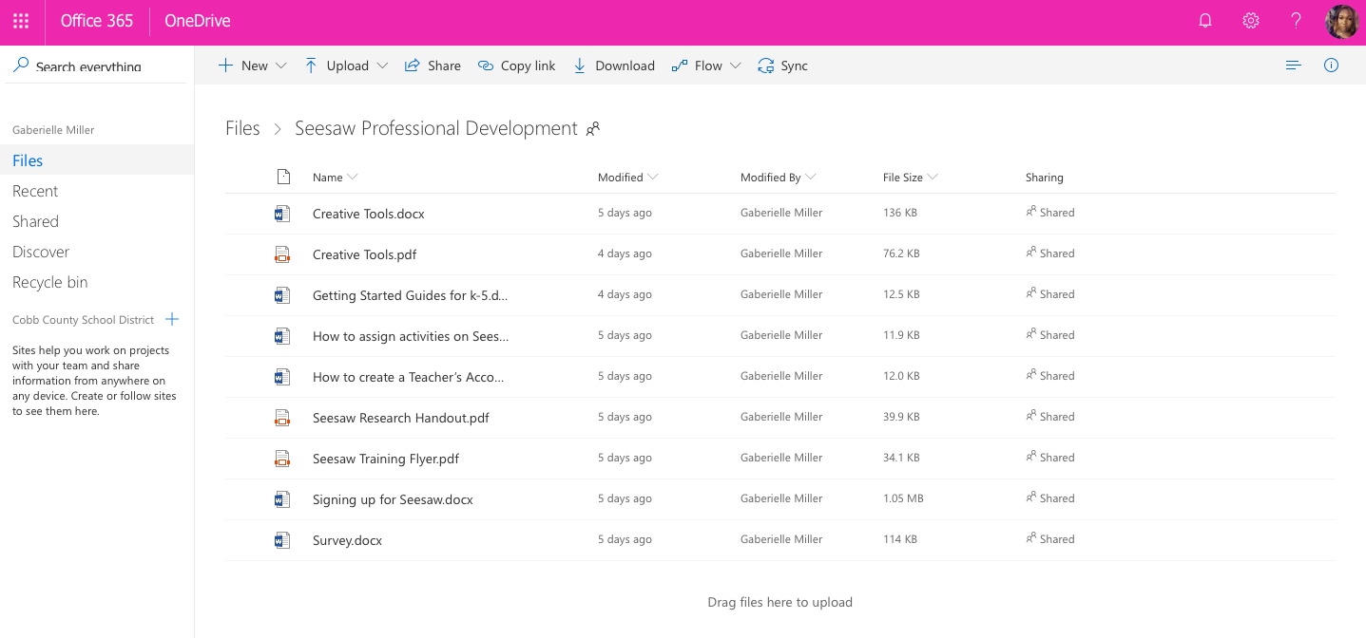
Evaluation Summary of Results:
Summary of Results
Additional Elements:
- Creating a Teacher’s Account (Screencast Video)
- How to Assign Activities in Seesaw (Screencast Video)
- Seesaw Flyer
- Seesaw PowerPoint
- Instructional Agenda

References
App Store Preview. (2018). https://itunes.apple.com/us/app/seesaw-the-learning-journal/id930565184?mt=8
Instructional Technology. (2017). http://www.cobbk12.org/centraloffice/InstructionalTechnology/
Seesaw for schools efficacy study. (2018). https://help.seesaw.me/hc/en-us/articles/115005752703-Seesaw-For-Schools-efficacy-study
Technology services. (2016). http://www.cobbk12.org/centraloffice/InstructionalTechnology/WhatisTTIS6Quest.pdf

